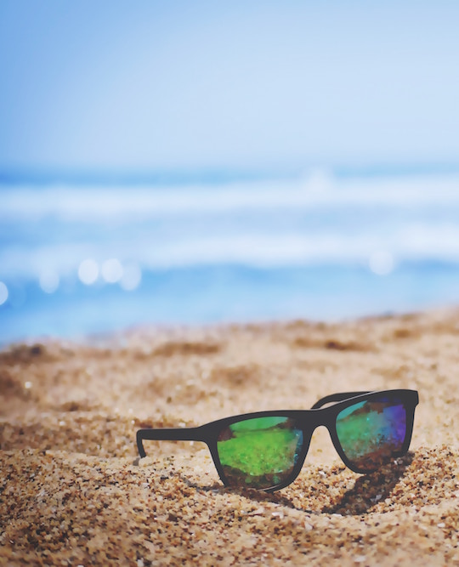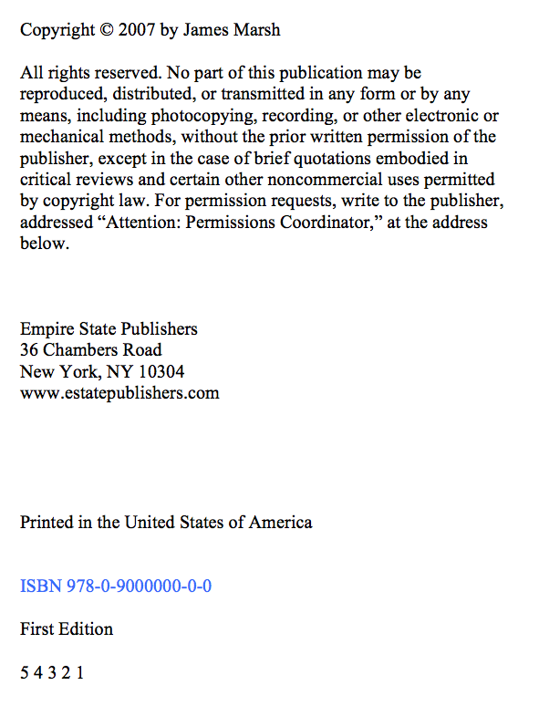

**Fifty Tips**

**for Fun at the Shore**

James Marsh

**Empire State Publishers**

Scroll down to view the second source



Shore Leave Online

www.shoreleaveonline.com/dayattheshore

Travel Ideas News Hotels Dining Cruises SUBSCRIBE

Shore Leave

Online

A Day at the Shore

Sandrine Boudreaux | May 31, 2015

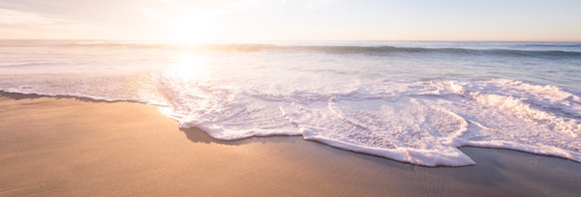

A day at the shore has long been a staple of summer fun. Every year thousands flock to our nation’s shores to spend time together, and get fresh air and exercise while enjoying some of the most breathtaking vistas in nature. A day at the shore can be filled with any number of activities capable of creating lifelong memories, but preparation is key to having a good time. So before you pack up the family and hit the beach, here’s what you need to know for a day at the shore.